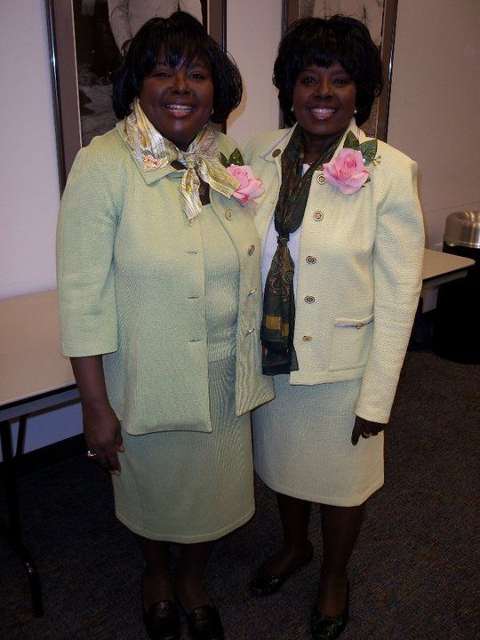

Congratulations

**Beau John Doe**

We are thrilled to support you as a participant in the 2013 Beautillion of the Phoenix Chapter of Jack & Jill of America, Incorporated

Continue to allow your strong courageous spirit to lead you to your goals.

May God Continue to Bless You,

Uncle and Aunt Doe